Step 1: Open PowerShell as Administrator
- Press Windows.
- Search for PowerShell.
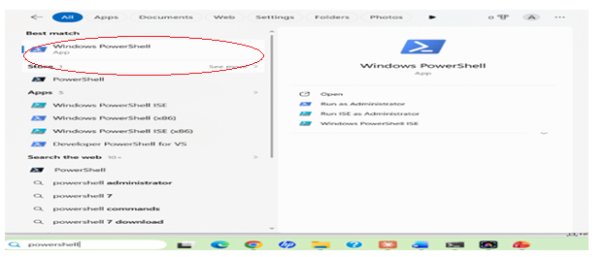
- Right-click Windows PowerShell.
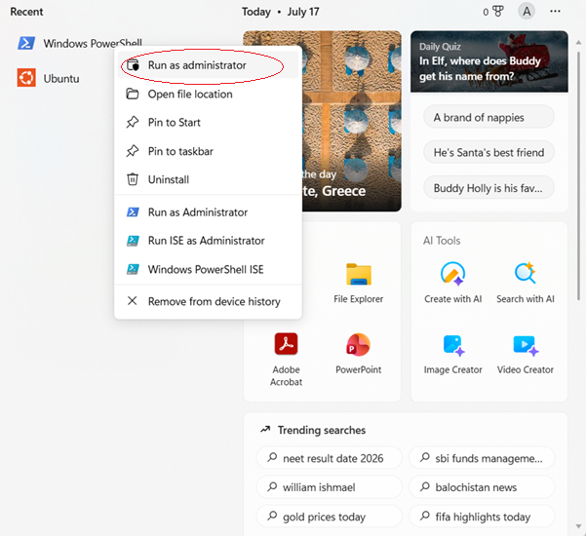
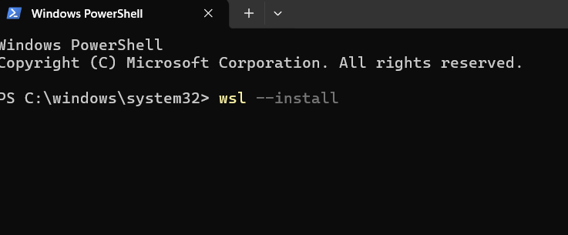
Step 3: Restart Your Computer
After installation, restart your PC when prompted.
Step 4: Complete Ubuntu Setup
After restarting:
- Ubuntu opens automatically (or search for Ubuntu in the Start menu).
- Wait for the installation to finish.
- Create a Linux username.
Example:
Enter new UNIX username: anusha
Step 5: Create a Password
You'll then be prompted to create a password.
New password: ****
Retype new password:****
Step 6: Update Ubuntu
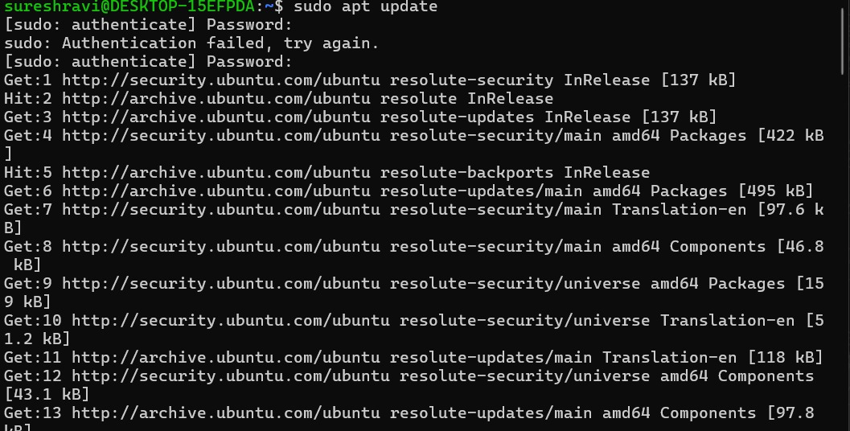

Step 7: Install GCC (C Compiler)

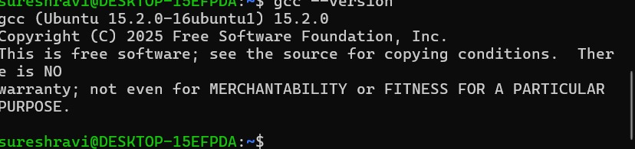
Step 8: Verify the Installation

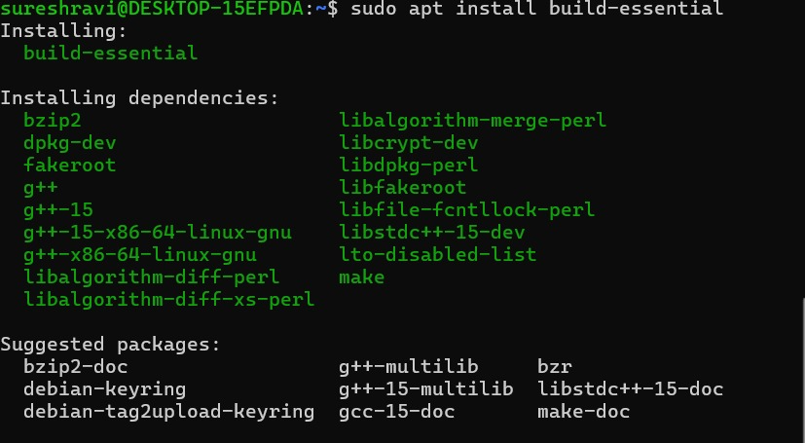
Example: nano process.c
Step 9: Create Your C Program
#include <stdio.h>
#include <unistd.h>
#include <sys/types.h>
#include <sys/wait.h>
#include <stdlib.h>
int main() {
char cmd[100]; printf("Enter a Linux command: ");
scanf("%s", cmd);
pid_t pid = fork();
if ( pid > 0) {
printf("\nParent Process\n");
printf("Parent PID : %d\n", getpid());
printf("Child PID : %d\n", pid); wait(NULL); }
else if ( pid == 0) { printf("\nChild Process\n");
printf("Child PID : %d\n", getpid());
printf("Parent PID : %d\n", getppid());
execlp(cmd, cmd, NULL);
perror("Command failed"); exit(1);
} printf("\nChild process completed.\n"); return 0;
}
Example: nano process.c
Step 10: Compile the Program
